USB Type-C Power Delivery Analyzer Introduction

KEY FEATURES

Introduce the power delivery analyzer.

How to setup the Analyzer.

How to capture power delivery data with the Analyzer.

The USB Type-C Power Delivery Analyzer base on EFM8BB3 is intended to bring a tool to capture the power delivery data on the CC pin to aid the analysis of USB Type-C application. The analyzer consists of two parts, the Analyzer device be implemented by EFM8BB3 which can capture all of the physical layer package data, and the GUI tool which can receive all of the captured data from Analyzer device and analyze it, and provide a flexible view for the analysis result.

This documentation will introduce the basic system architecture and provide a operation steps for how to analyze the power delivery behavior with the help of the tool.

# Introduction

USB has evolved from a data interface capable of supplying limited power to a primary provider of power with a data interface. Today many devices charge or get their power from USB ports contained in laptops, cars, aircraft or even wall sockets. Users need USB to fulfill their requirements not only in terms of data but also to provide power to, or charge, their devices simply, often without the need to load a driver, in order to carry out “traditional” USB functions.

USB Power Delivery is designed to enable the maximum functionality of USB by providing more flexible power delivery along with data over a single cable. Also it enables alternative modes of operation by providing the mechanisms to discover, enter and exit Alternate Modes. The specification also enables discovery of cable capabilities such as supported speeds and current levels.

The USB Power Delivery specification defines how USB Devices may negotiate for more current and/or higher or lower voltages over the USB cable (using VBUS or CC wire as the communications channel). And defines mechanisms to discover, enter and exit Modes defined either by a standard or by a particular vendor. And also defines the mechanisms to discover the capabilities of cables which can communicate using Power Delivery.

The USB Power Delivery Analyzer (PD analyzer) base on EFM8BB3 can monitor the PD package data on the Control Channel lines CC1 and CC2 through USB Type C connection, and don’t need intrusive the original system. It can aid to analyze the behavior of the whole USB Power Delivery System to promote the development of new USB PD product or troubleshoot the issue of the PD system.

The system architecture of PD analyzer be illustrated in figure 1.1. The PD analyzer be connected to analysis computer through a USB-to-Uart Bridge for data transfer. The target device should connect the Analyzer’s type-c receptacle, and the plug of Analyzer should connect to another type-c device, typically, it is a source port.

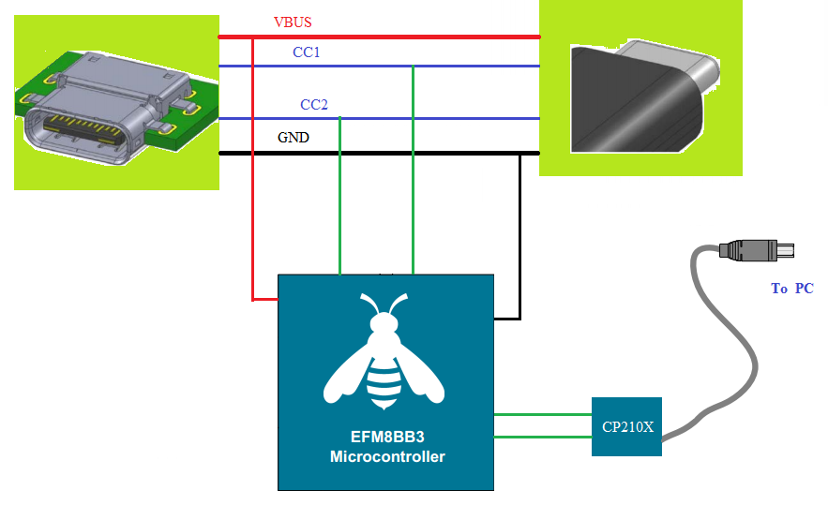

Figure 1.1. System Architecture of PD analyzer

Note:

The system performance may be degraded with a high loading of USB system in the analysis computer, and the PD package data between the Analyzer device and PC may be lost in severe case.

## Hardware Requirement

EFM8BB3 with 64K flash and 4K XRAM. It’s recommended to adopt the EFM8BB31F64G STK board to setup the PD Analyzer tool.

## Software requirement

The GUI tool be implement with python which be supposed compatible with major system. Such as Windows, Linux, MacOS.

And because the PD analyzer need to transfer data with the analysis computer through USB-to-Uart bridge, so the VCP driver also be requested depend on the bridge.

## Overview of the GUI

As below is the main perspective of the PD analyzer GUI, it comprises the following elements:

* Menu bar
* A message view window which list all of the captured PD package data.
* A Raw Data view window

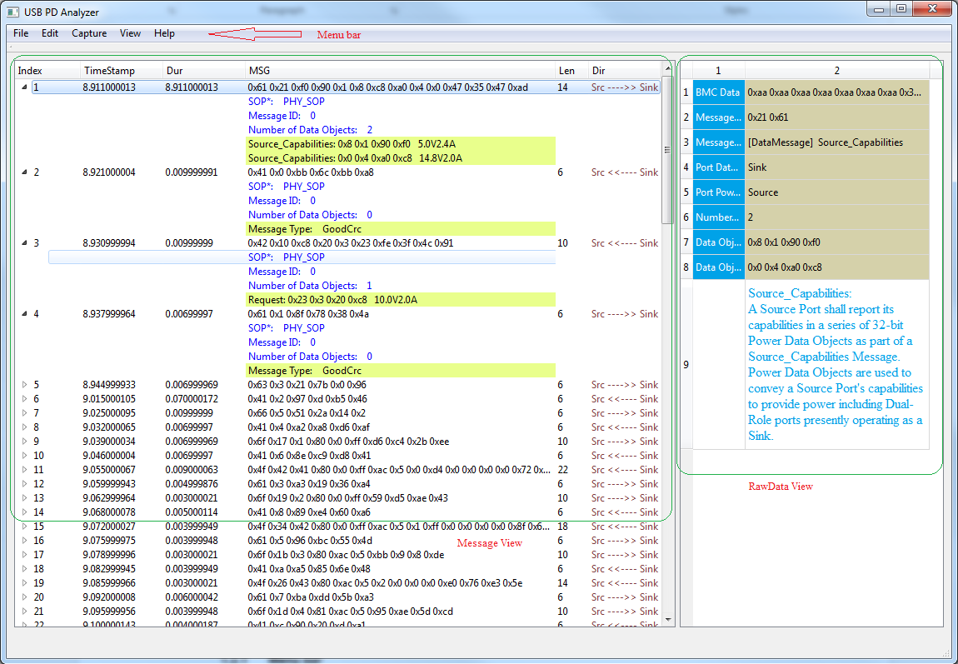

Figure 1.2. Main perspective of the PD analyzer GUI

### Menu bar

The menu bar of the GUI tool list all of the available function of the analyzer tool, as below is the description about the major functions.

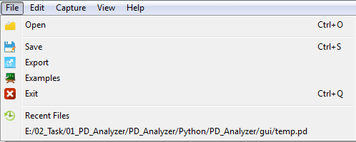

**Open** Opens a previously saved file

**Save** Saves a data acquisition in a file.

**Example** Opens an example file

**Exit** Exit the GUI tool

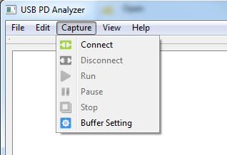

**Connect** Create the connection with PD Analyzer device

**Disconnect** Disconnect with the PD Analyzer device

**Run** Starts recording USB PD traffic

**Stop** Stop recording

**Buffer Setting** Set the buffer for recording

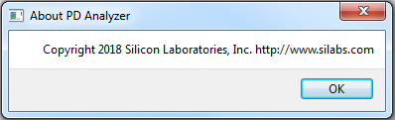

**About** License information about the PD Analyzer.

### Message view

The message view window be consist of a list that displaying all USB protocol elements. The analysis software lists PD package on the left side of the display. Each PD package includes the SOP, Message ID, Number of Data Objects and Message Type information, also the payload and absolute time of each PD package be expressed in the view. And the PD package transfer direction is indicated with an arrow.

### Raw Data View

The Raw Data View will show more information about the selected power delivery package. In addition to the basic PD package information be provided by Message view, this display view allows the user to check the raw data (5B encoded) of each package, and all of the detailed information will be listed, also a brief description about each control message or data message be added to help the user understand the meaning of the PD package further.

# Setup the Analyzer

## Setup the Analyzer Device

The USB Power Delivery Analyzer (PD analyzer) device be implemented with EFM8BB3. EFM8BB3 has a Configurable Logic block which be consisted of multiple Configurable Logic Units (CLUs). CLUs are flexible logic functions which may be used for a variety of digital functions, such as replacing system glue logic, aiding in the generation of special waveforms, or synchronizing system event triggers. The USB PD analyzer adopt the CLU as a BMC decoder, the module can decode the BMC code independently of the CPU, has the benefit of reducing the workload of the CPU.

The PD analyzer device be consisted of three parts, EFM8BB3 STK board, CP210x USB-to-Uart bridge, a Type-C receptacle and plug connector. As below is the prototypes of the PD Analyzer device.

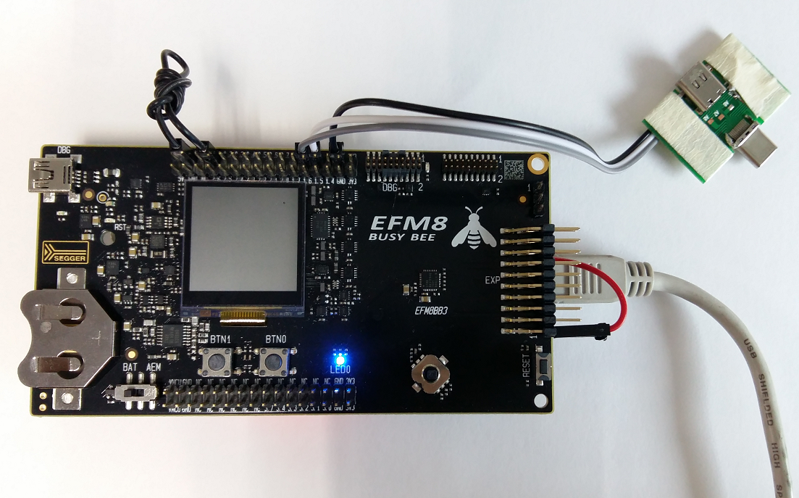

Figure 2.1. The Top View of the PD Analyzer device

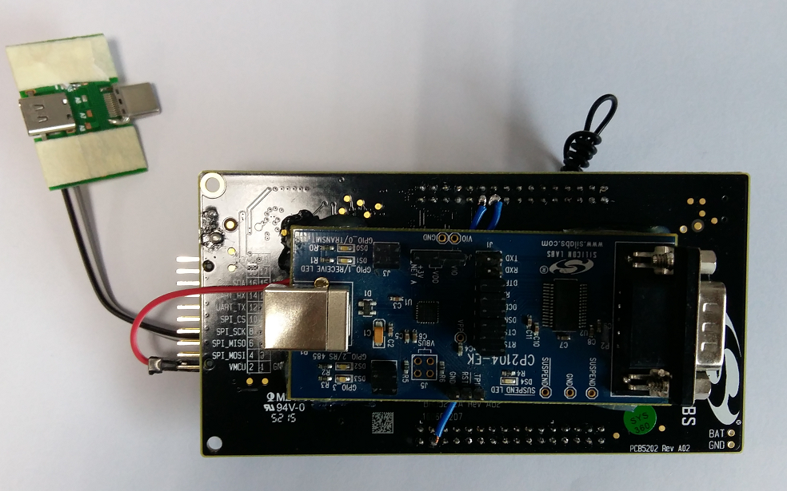

Figure 2.2. The Bottom View of the PD Analyzer device

**PIN Connection:**

The P0.1 of STK board should connect to GND for a reference GND. And P1.1 P1.2 is the input channel of CC pin, please connect them with the Type-c connector’s A5 and B5 pin. Also we should connect the P1.7 and P2.0 to the Rx and Tx pin of CP210x for data transaction.

## Setup the Software

There is a USB-to-Uart bridge in the system for the data transaction between the Analyzer device and analysis computer, so the VCP driver is necessary for the system’s work. And the latest driver be updated to the webpage as below.

<http://www.silabs.com/products/development-tools/software/usb-to-uart-bridge-vcp-drivers>

The GUI tool “PD Analyzer.exe” be implemented with python and packaged by pyinstaller, user can just run the application without installing.

# Capture PD package data

## Connection Check

Ensure that the PD Analyzer device is connected to the analysis computer and the power is on.

Launch the PD Analyzer application by double clicking “PD Analyzer.exe”

At the main window, click the Capture -> Connect menu to create the connection between Analyzer device and computer. The Connect menu will become disabled if connection be established, otherwise a warning message window will be popped to info the connection failed. And please reset the analyzer device and try to connect it again.

## Capture Data

After ensuring the connection, please start to capture the PD package by clicking the Capture -> Run. And then connect the target Type-c device with the receptacle of the connector, and the plug of the connector should be connected to other Type-c source.

For a quick demo, simply plug the USB Type-C power adapter into the receptacle, and plug the connector into the Macbook.

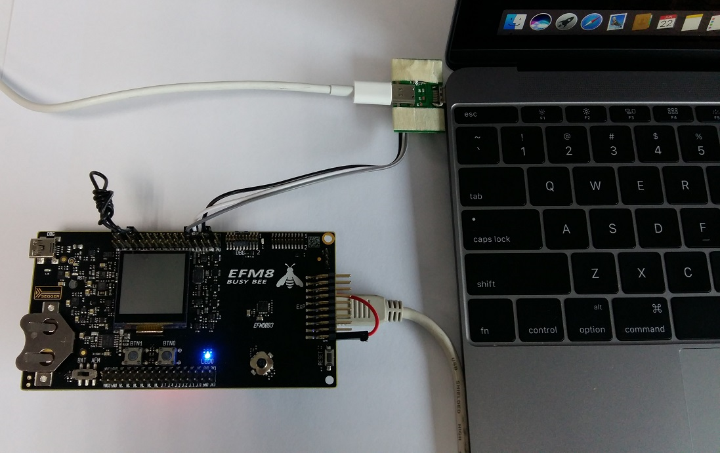

Figure 3.1. The Overview of the PD Analyzer

A recording progress bar at the bottom of the window will show the capturing progress.

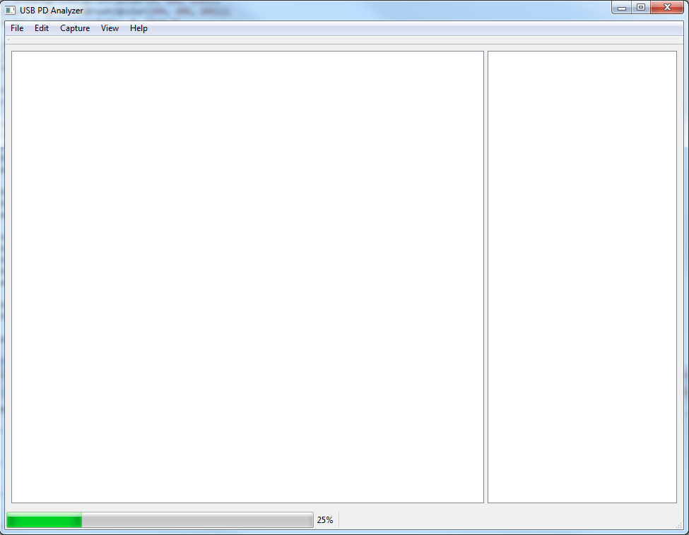

Figure 3.2. Recording progress

After recording done, the application will analysis the captured data immediately, and show the analysis result in the Message view window.

The default recording buffer setting is 10K, user can enlarge the buffer setting to capture more data one times.

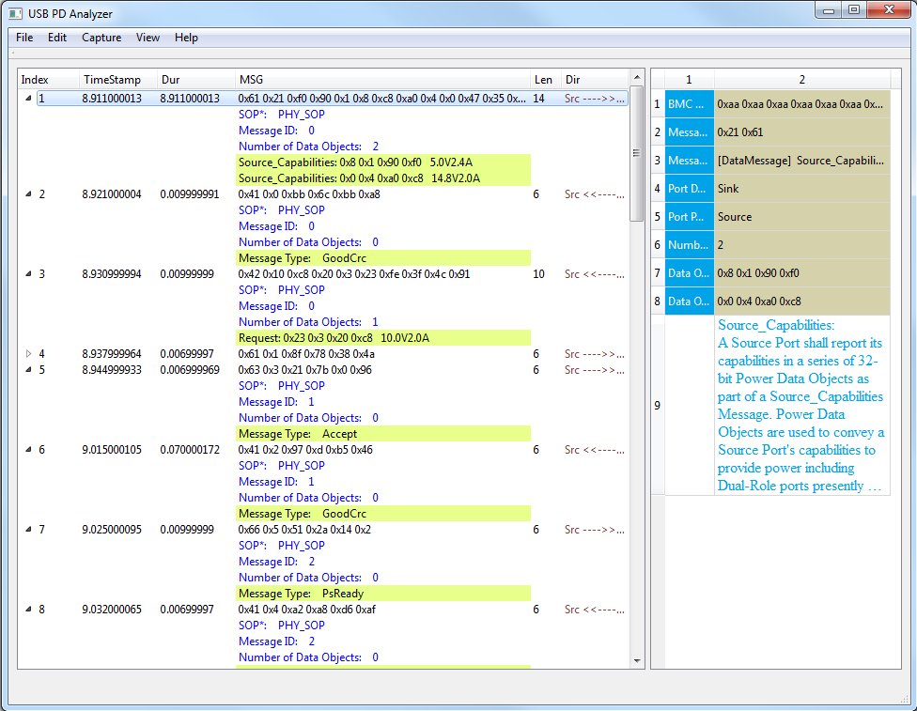

Figure 3.3 Analysis result

What the captured PD package data can be stored with the clicking File -> Save. And some example PD data be provided for user reference.

# Conclusion

The USB power delivery analyzer is a versatile, easy to use EFM8BB3 STK board to captured the PD package data on the CC pin, the GUI tool aid the Type-c product developer to analysis the PD message to troubleshoot the abnormal behavior of the product.